World Record

A Coventry made pocket watch recently broke a world record when it sold for over £2 million.

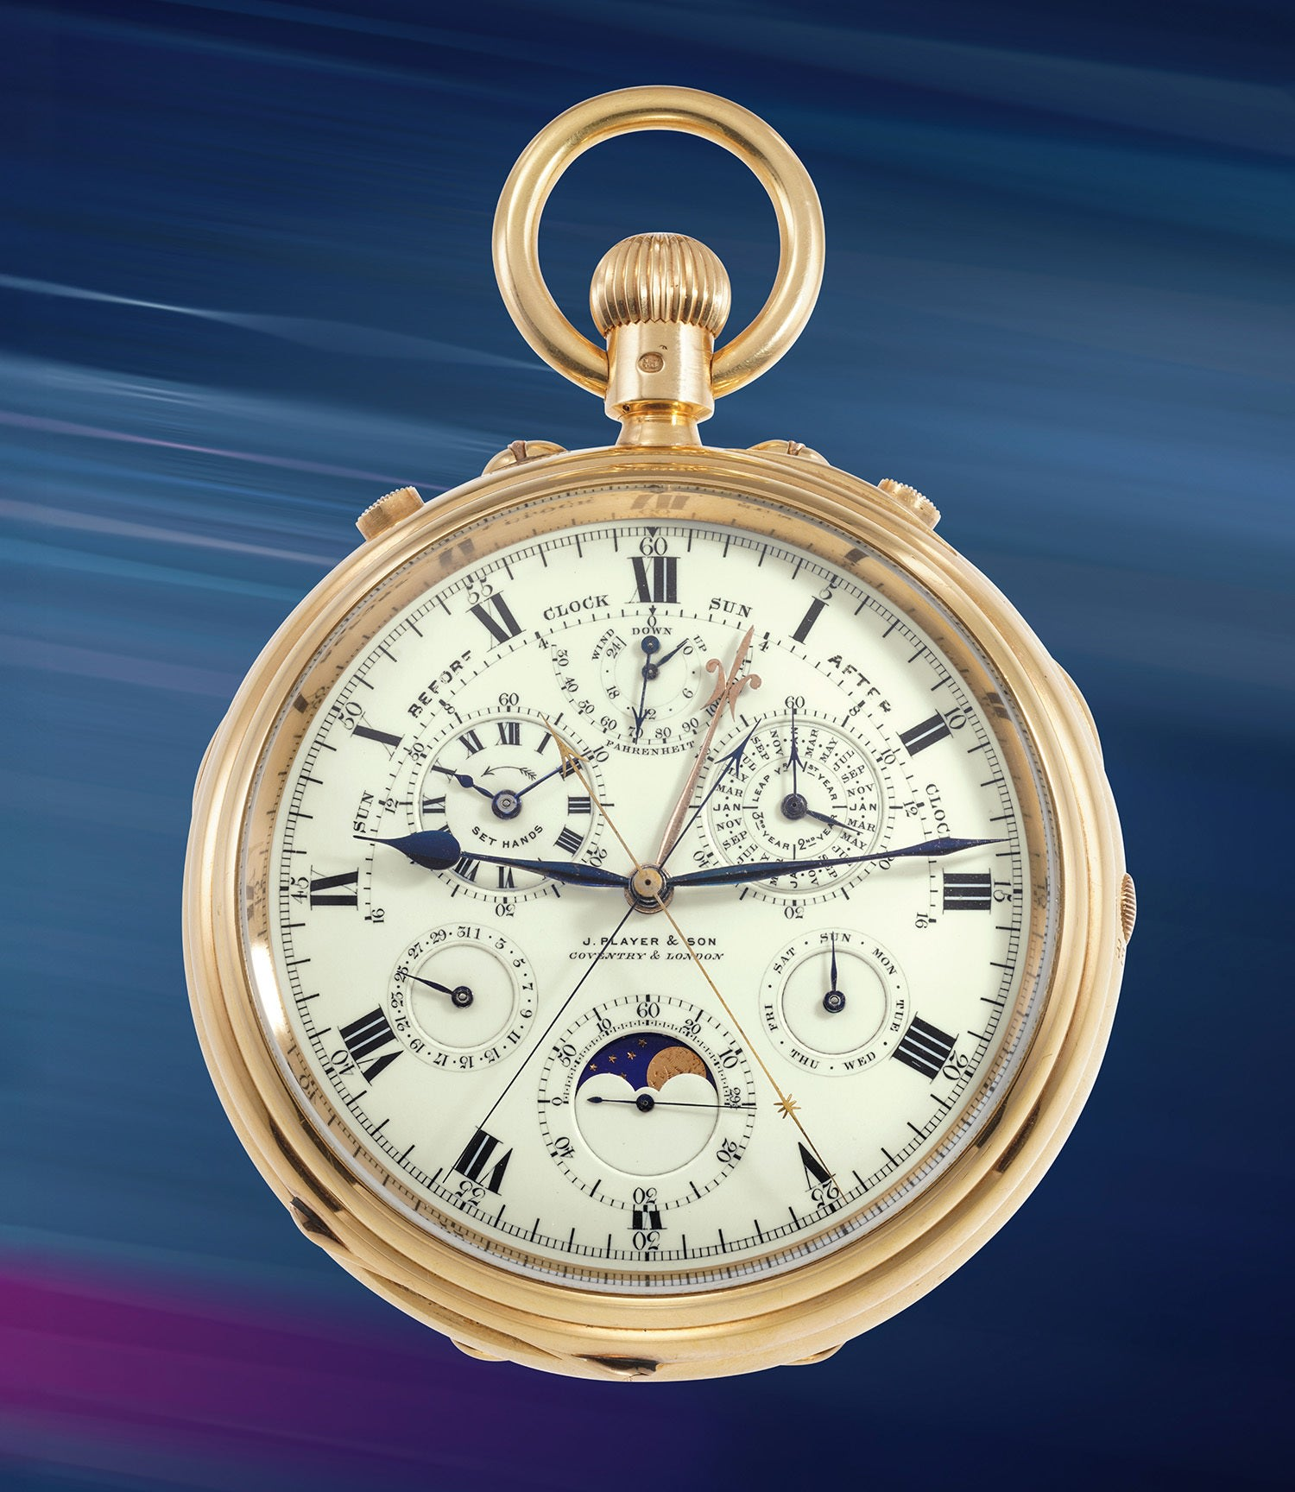

Watch made by J.Player in Coventry in 1907

In early November 2025 Geneva hosted one of the largest watch auctions of the year. Many notable watches and clocks were offered for sale over the weekend.

Auction
A pocket watch made by J. Player & Son in Bedford Street Coventry set a new world record for a British-made pocket watch at the auction. It sold for 2,238,000 Swiss francs equivalent to £2,122,896 following an estimated sale price of £1m. The auction was attended by 800 people but there were 1,885 registered bidders based in 72 different countries.

Hyper Complication
The auction brochure had stated that the watch "demonstrated the incredible technical prowess of English watchmaking at the time"
The timepiece had been described by some as a hyper complication. A complicated watch is one with any function beyond a basic time display of hours, minutes and seconds. The phases of the moon a perpetual calendar, stopwatch, an alarm, tourbillon are common additional features. This particular watch had taken four years to build.
The seller had acquired the watch in 1974 and had owned it for 51 years. Both the buyer and the seller wished to remain anonymous. The auctioneers Phillips indicated that the identities of both parties was confidential.

Family Connection
Carl Player from Coventry, the great-great grandson of Joseph Player attended the auction in Switzerland and was allowed to handle the timepiece. He said that he felt a connection to his ancestor when he held it. J. Player & Son had a reputation for high quality complex timepieces and were pioneers of keyless watches. They had both Admiralty and Kew approval for their products and supplied devices to the Royal Observatory.

Legacy
This watch was described in the auction brochure as "one of the most complicated English timepieces ever made". At the beginning of the twentieth century British watchmaking was in decline due to reluctance to use mass production techniques. However watches produced were still renowned for exceptional quality and craftsmanship. The legacy of precision skills laid the foundation for Coventry's success in cycle, car, aerospace and machine tool industries.

