Earlsdon Cycling Pioneers

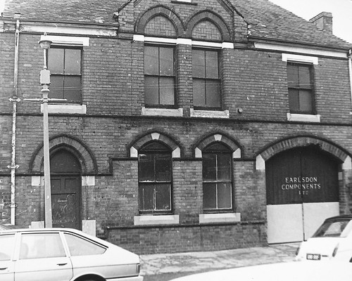
Old Nail Factory Moor Street Earlsdon
In 1885 the Old Nail Factory was built in Moor Street Earlsdon by William Pitt who soon became unpopular with local residents. His forge produced smoke and local ladies complained of smuts when they hung out washing. In 1889 Fred Allard set up business with his partner William Pilkington in these premises to produce bicycles. He had been a World Champion safety bicycle rider two years previously in 1887. The Allard Cycle Company was reasonably successful.

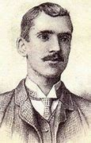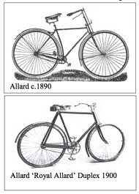
Fred Allard
The partnership was dissolved and in 1902 Allard Cycles merged with Birmingham Manufacturing Co. and became the Rex Company. The business then moved to larger premises in Osborne Road.
Rex Acme went into liquidation in 1923 and the factory was sold to the Standard Motor Co. who in turn sold it to Coventry Bicycle Co. in 1928. Coventry Bicycle Co. then moved there from their site in Fleet Street Coventry.
Coventry Bicycle had adopted the brand name Three Spires in 1927 and from the early 1930s produced both Three Spires & Eureka (lower price) models in Osborne Road. In 1936 the company purchased Triumph Cycles and also Trivelox Gears. Trivelox production remained in Priory Sreet.
Walter Greaves was born in Spring 1907 in Yorkshire and lost an arm at just 14 years old in a road accident. The damage to his left arm resulted in amputation below the elbow. His interest in communism made it difficult for him to find work as a young man. Greaves was a keen cyclist and wanted to attempt the World Endurance Record. However, he struggled to attract sponsorship. Eventually Three Spires Cycles struck a deal where they supplied a cycle and provided a small weekly wage. In return for sole advertising rights.

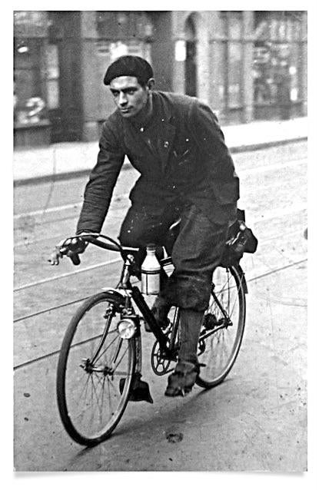
Walter Greaves
Walter’s bicycle had to be adapted. The handlebar was fitted with a twist grip for changing gear and a single lever was employed to operate the brakes. The modifications were 5 days late in being completed. This obviously put him at a severe disadvantage. T he record attempt was due to start on 1st January 1936 and finish on 31st December.
Newspaper reports recorded that he fell off twice in the first 10 miles and slipped on tram lines and fell again. It was a particularly harsh winter with snow and ice present until the end of February. In July Walter was hit by a car and spent 2 weeks in hospital recovering from an operation. He arrived at Hyde Park on 13th December and lapped the Serpentine to equal the record set by Ossie Nicholson in 1933. A reception was held in a hotel that evening where he was offered champagne. A strict teetotaller he said “When I want to poison myself I’ll do it with arsenic”
Walter Greaves covered 45,383 miles to break the existing record, which was in turn broken by another English man Bernard Bennett the next year. He had a cycle shop in Bradford where he built cycle frames until the late forties when a fire put him out of business. He then moved to Cravens Forge by the Leeds Liverpool Canal and ran a café. Walter and his wife lived above the café for some time. In 1979 he fell victim to Parkinson’s disease and finally passed away in 1987 at the age of 80.

