The Grand Complication

Joseph Player & Son was formed in 1858. Joseph having been born in London c.1832. The company gained a reputation for high quality and introduced keyless watches to Coventry. They had both Admiralty and Kew approval for their products. At one time employing 56 men and 23 boys in their facility in Bedford Street Earlsdon Coventry. He died in Allesley in 1895 aged 63 and his son J W Player then took over the running of the firm.

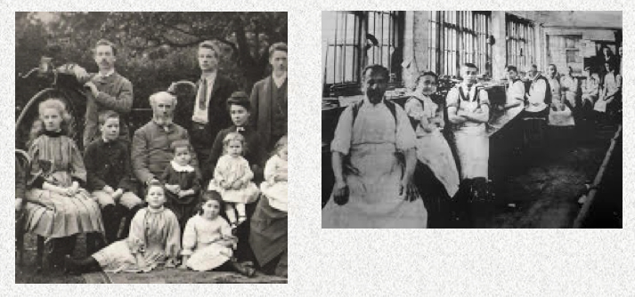

In 1905 the company was commissioned to produce a timepiece for J P Morgan the famous American banker. The timepiece became known as the Grand Complication and was double sided in a solid gold case and weighed 1.75 pounds. It told the time, charted sunrise and sunset, traced solstices, equinoxes and had an annual calendar. After taking 4 years to build it was finally delivered in 1909 at a price of £1000. Unfortunately John Pierpont Morgan didn’t have long to enjoy it as he died in 1913 at the age of 75.

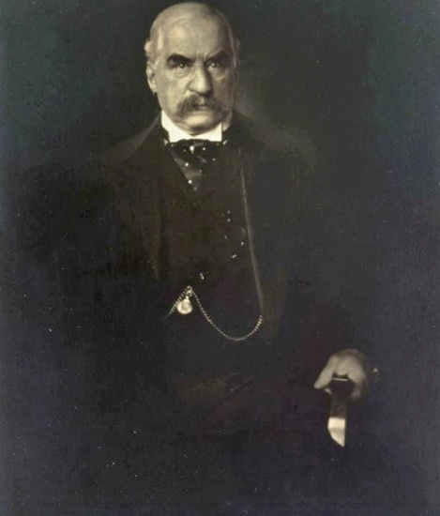

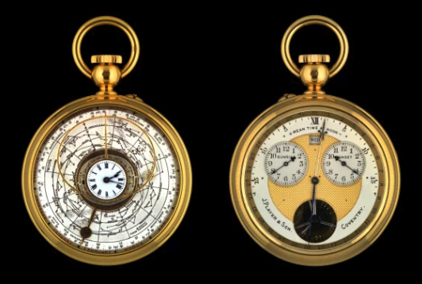

By 1947 it belonged to Benjamin Mellenhoff the chief watchmaker & repairer at Tiffany & Co. in New York. In 1974 Jan Skala, described as a New York antiquarian, based on 47th Street Manhattan declared that he now owned the watch, but wouldn’t disclose how he’d acquired it.
Robert Loomes chairman of the British Horological Society remembered John Player visiting Loomes & Co. in Stamford. At the time he mentioned Morgan and stated with pride that one of the most famous men in the world had commissioned the watch.

In 2020 Daniel Miller a staff writer with the Los Angeles Times decided to investigate further. His enquiries led him to speak to Geza von Habsburg archduke of Austria & chairman of Christies in Switzerland. He remembered Skala and decided to message a friend Osvaldo Patrizzi about the timepiece. Eventually Patrizzi revealed to Daniel Miller that Skala had sold the watch to a collector named Samuel Bloomfield for $250,000.
Samuel was living in San Diego but had been president and chief engineer of Swallow Airplane Co. in Wichita. Kansas.

When Bloomfield and his wife died there was no record of the watch. Patrizzi wondered if it had been sold to the Sultan of Oman - Qaboos bin Said an avid collector. The Sultan had worked directly with John Asprey the boss of Asprey of London – dealers in jewellery & luxury goods. One of Asprey’s sons suggested that Daniel should contact Andrew Crisford a London based horologist and director of Bobinet Ltd. London. Crisford confirmed that Bobinet had bought the Player watch in 1983 and sold it the same year to a customer. He was not prepared to disclose the sum involved, but indicated that the timepiece was still owned by that person.

Andrew Crisford would not name the owner, who didn’t want any publicity about this watch or his collection. However the owner fully understood the importance of it and felt privileged to own it. Crisford also confirmed that he’d seen it recently and it was perfectly safe.

Finally Daniel contacted Carl Player the great great grandson of John Player who is an accountant living in Coventry and updated him. Carl was shocked but really happy to know it was still around. He was secure in the knowledge that the timepiece was a treasured possession even though he didn’t know who the owner was.

